**Delete environment**

You can delete a sandbox environment to recover storage space and to remove Personally Identifiable Information (PII) data. In order to delete a production environment, you must first change it to a sandbox environment and then delete the sandbox environment. Trial and support environments can be deleted directly without converting to sandbox.

**Delete an environment**

1. Follow the steps in [Change the environment type](https://docs.microsoft.com/en-us/power-platform/admin/switch-environment).
2. Once the environment has been changed to sandbox, select it and then select **Delete**.

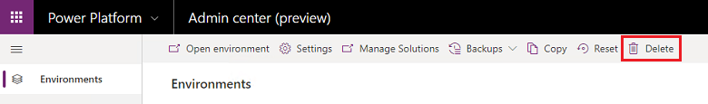

1. Select **Continue** to confirm the deletion.